Step 1: Please download Google Chrome first

Step 2: Open Google Chrome and click the icon in the red box on the upper right corner to enter the setting interface as shown below

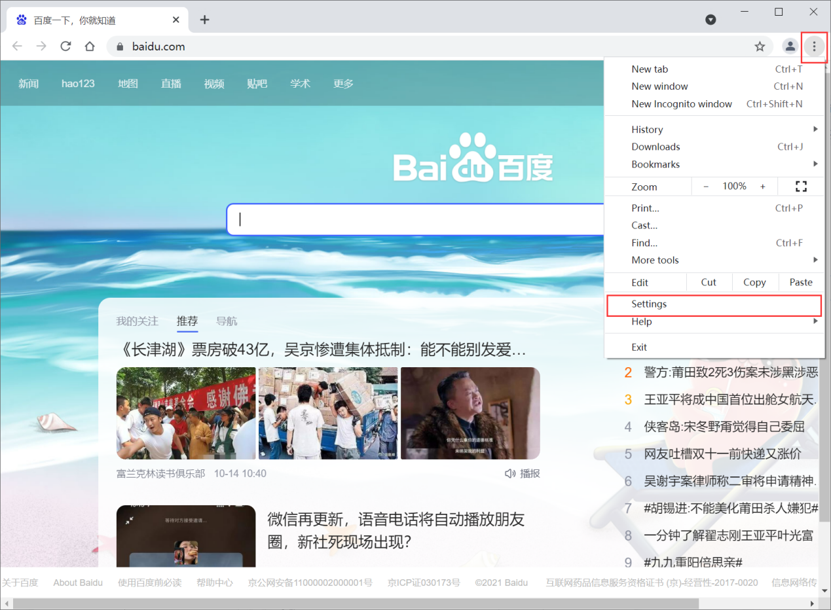

Step 3: Click on the extension to enter the extension interface

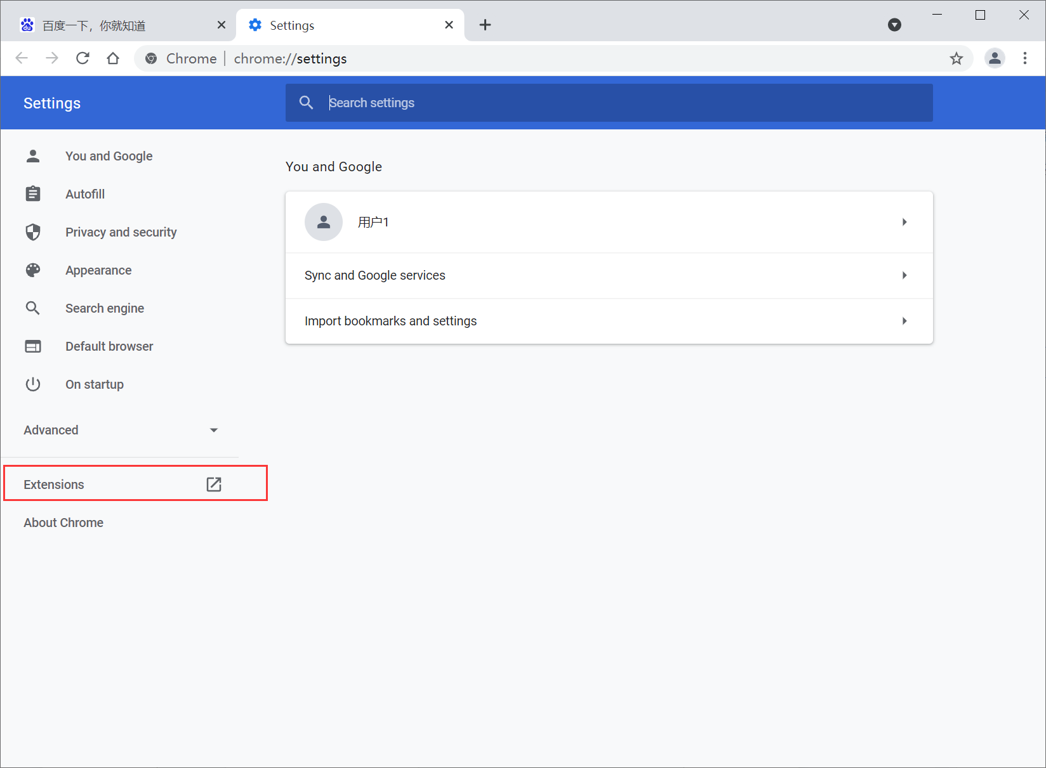

Step 4: Turn on the developer mode

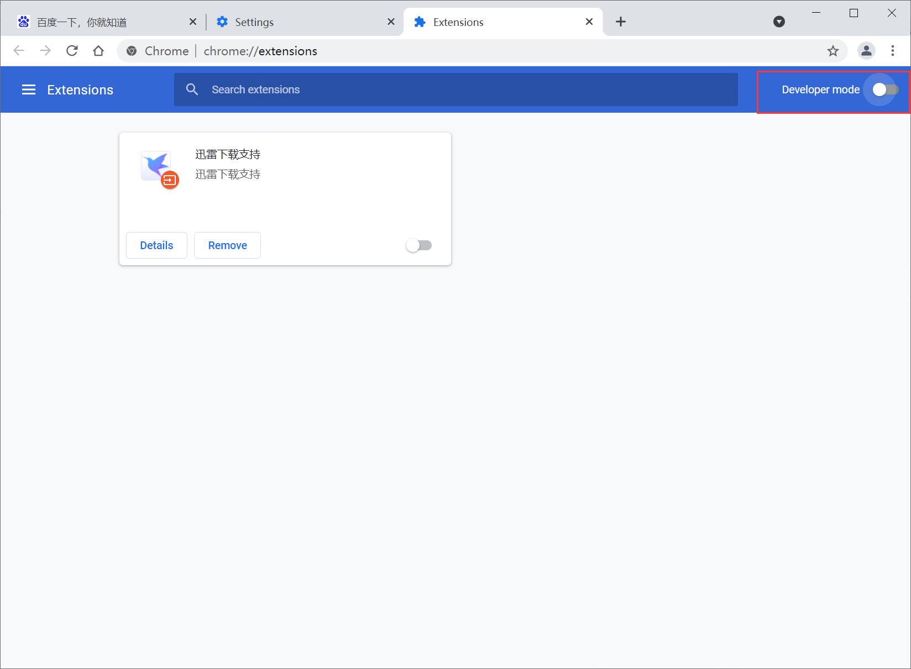

Step 5: Open the developer mode and click to load the unzipped extension

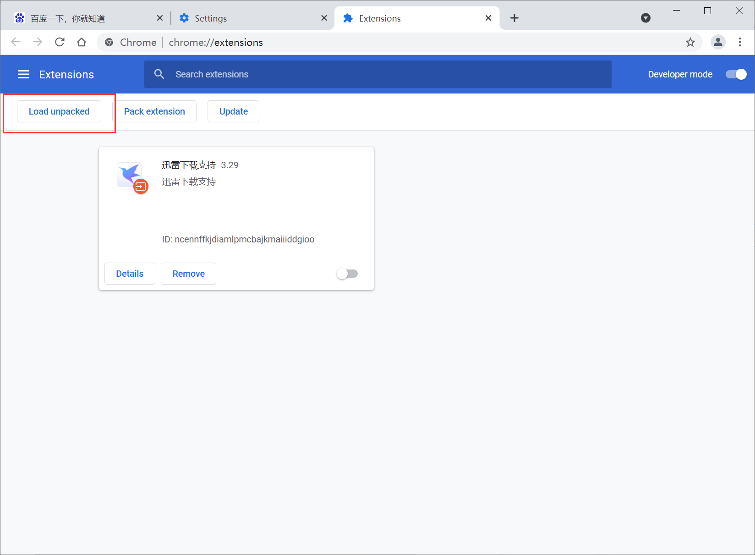

Step 6: Choose our chocolate_extend extension folder

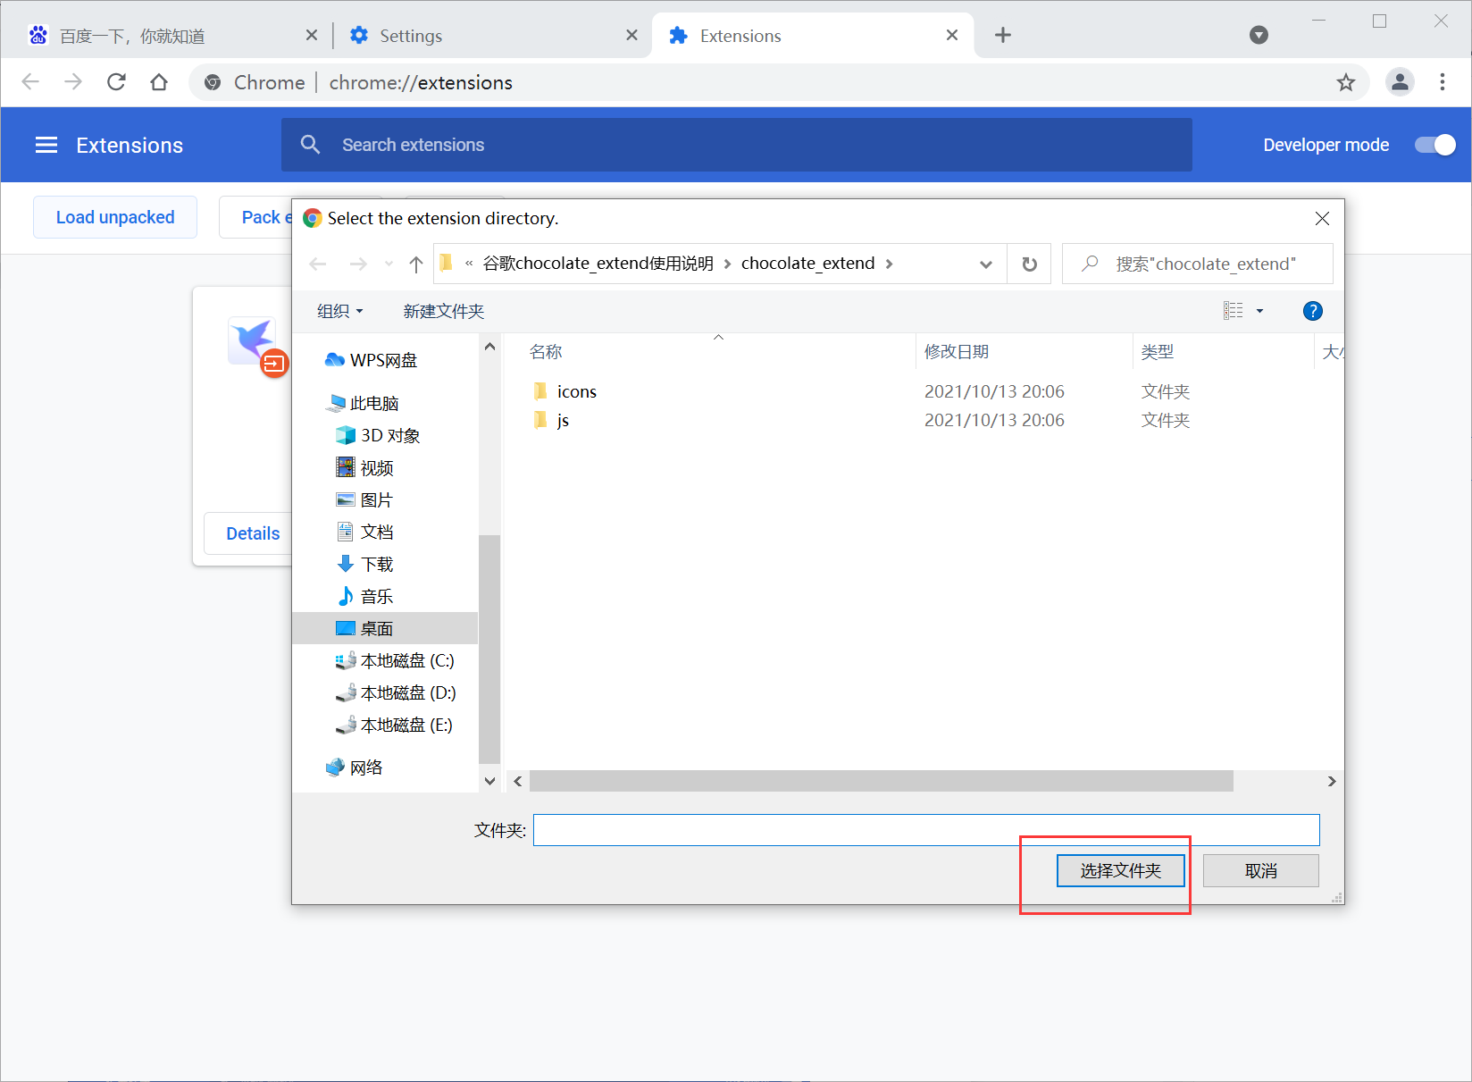

After opening, you can see that our extension has been loaded

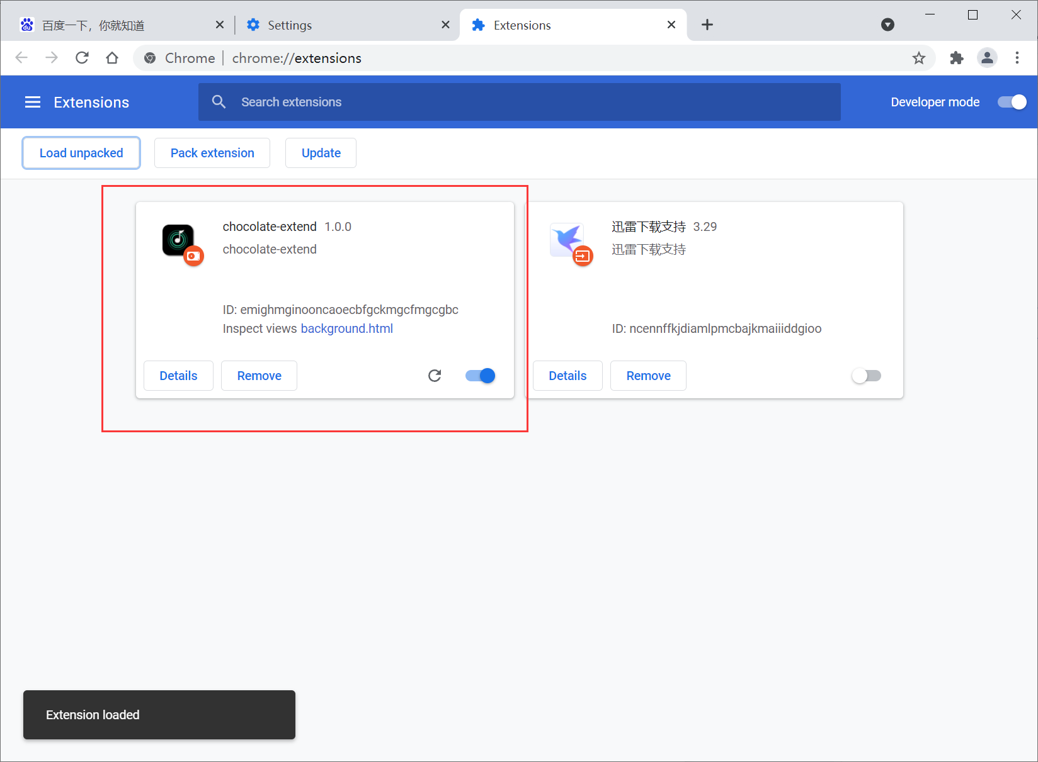

At this time, you can use chocolate to perform paragraph loop playback on the YouTube and Bilibili